2023 Poster Contest

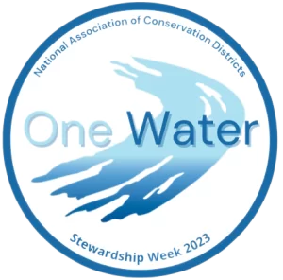
- The annual NACD (National Association of Conservation Districts) Poster Contest is open to all public, private, and home-schooled students in grades K-12

- Contest Grade Categories:
K-1 2-3 4-6 7-9 10-12

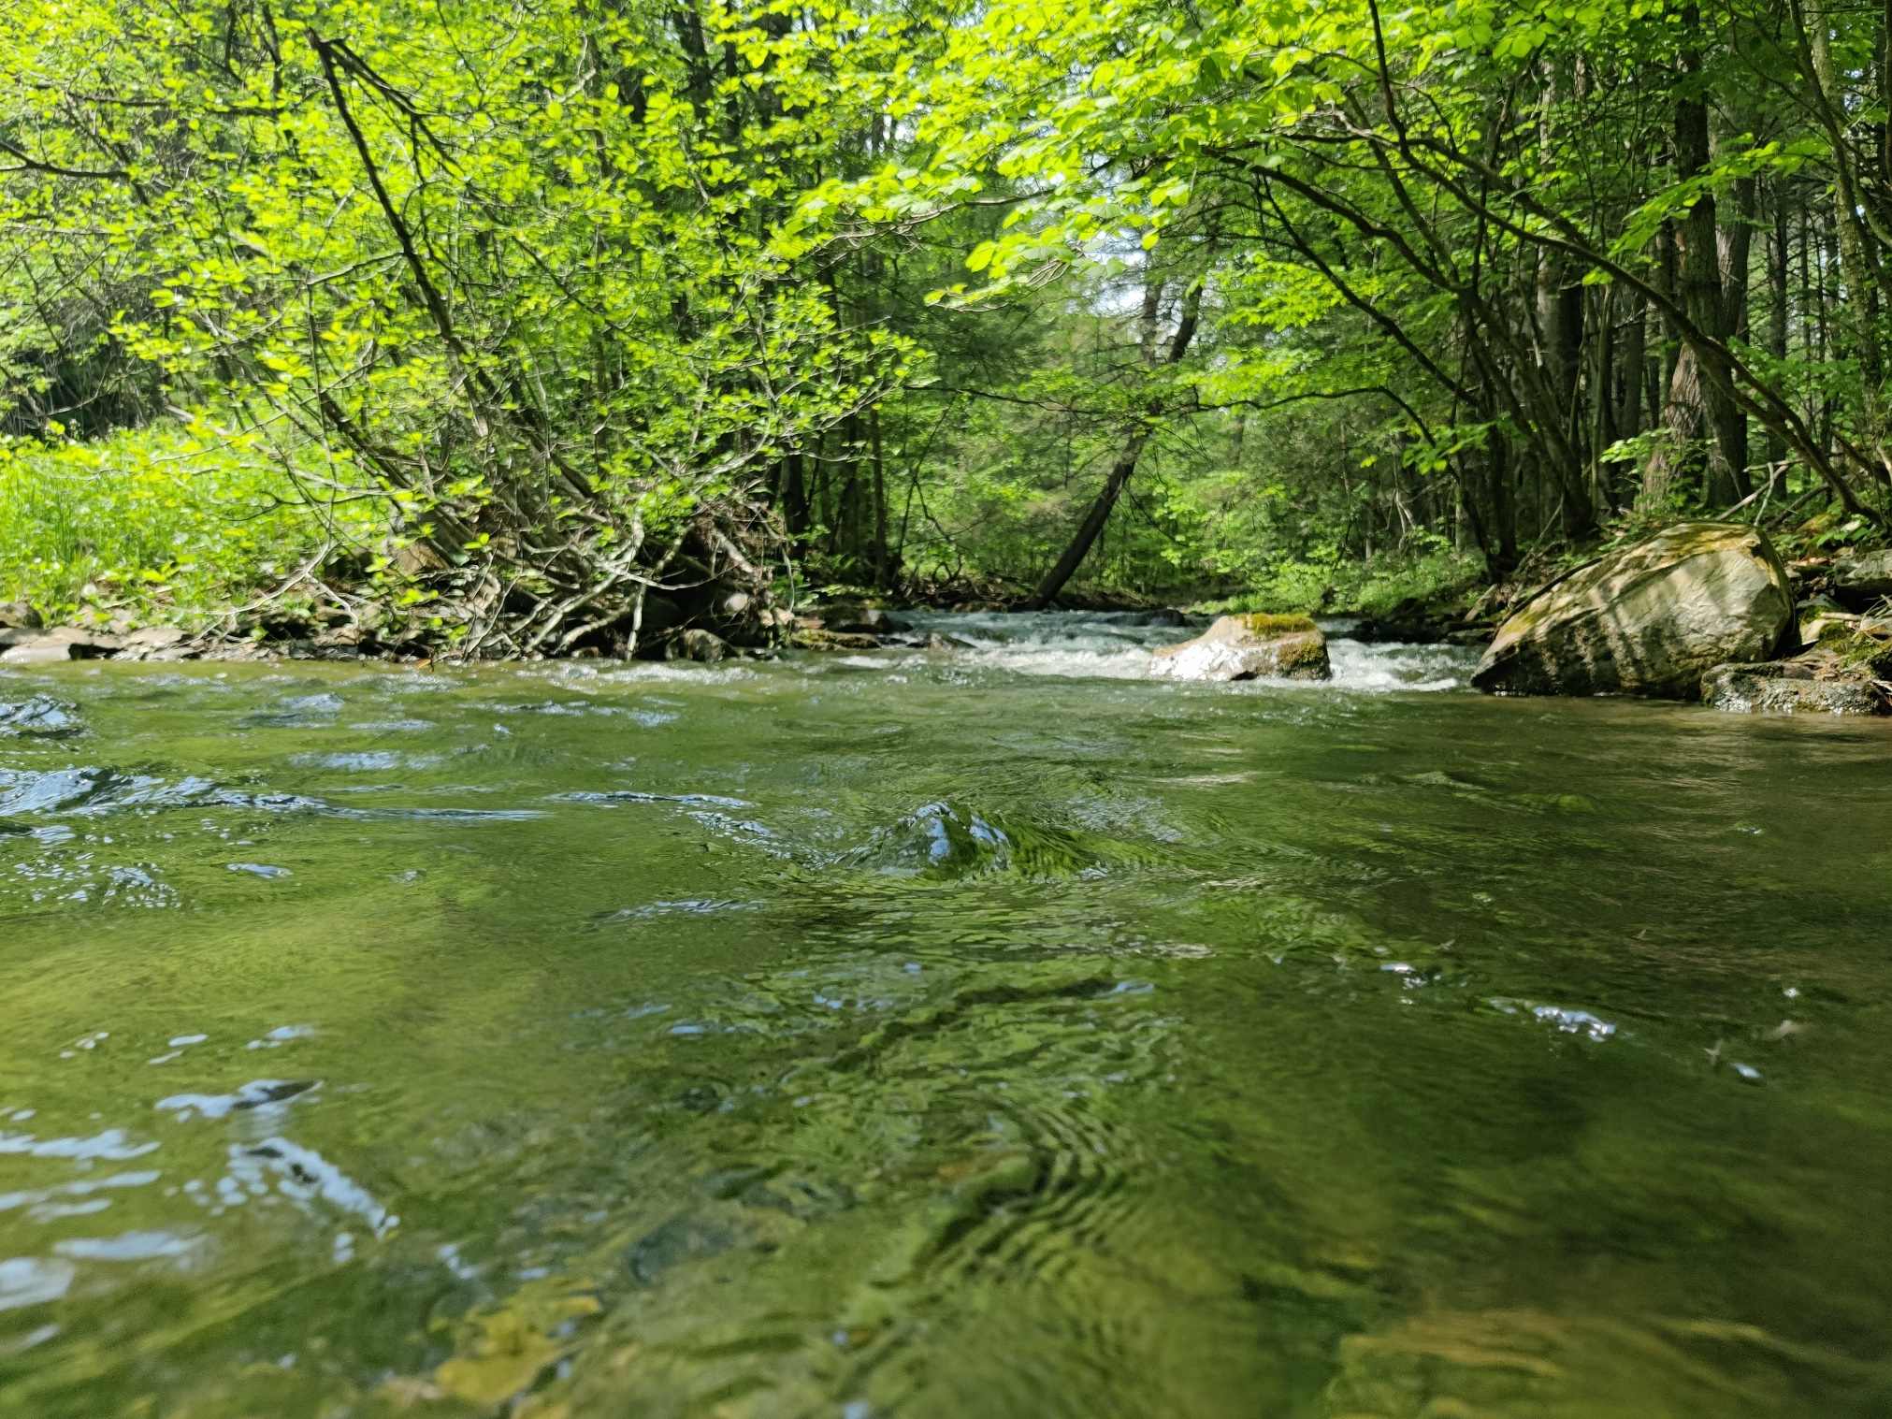
- The first-place poster in each category will receive a prize and entry to the national contest!

Submission Details:
- Due to Montgomery County Conservation District by June 2, 2023
- Hand drawn 14”x22” posters accepted, with a digital option for grades 7-12
- Official theme and/or logo “One Water” should be on each poster
- Accepting submissions from all K-12 students within Montgomery County
- Submissions can be mailed or emailed, must include Poster Contest Entry Form

Additional information and Entry Form can be found on the district website,
please click here:

Questions and submissions can be directed to:
Abigail Reiter, areiter@montgomeryconservation.org, (610) 489-4506 x24
143 Level Road Collegeville, PA 19426

